阿尔及利亚水电公司
2×Cat CG170-20天然气发电技术方案

2×Cat CG170-20 gas gensets technical scheme
for company general hydro electric algeria
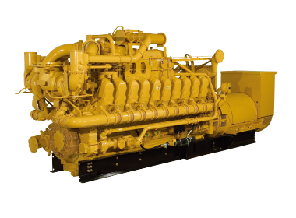

20220318

第一章、项目概述 Chapter one, project overview

1.1项目简介 project introduction
项目总装机容量要求:环境气温为-5--55度时,持续功率2*1.2MW，采用2台燃气内燃发电机组，本项目采用孤岛运行方式。
在上述气候条件下，两台发电机组必须在连续运行中提供最大功率，以满足电站的电能需求。
每一组将能够满足增压泵电动马达的直接启动。
发电机组组件将以一个框架的形式提供，便于维护操作。
The total installed capacity of the project is 2*1.2MW continus power at -5--55 °C . 2 sets gas-fired internal-combustion generating units are used. The project adopts island operation mode.
The two generating sets must be sized to provide maximum power in continuous service to meet the electrical energy needs of the station, and this the climatic conditions described .
Each group will be able to satisfy the direct start of the electric motors of the booster pumps.
The generating set assembly will be supplied in a package and in a single frame,

1.2工程概况 Project overview

1.2.1工程地点 Project location
工程地点：阿尔及利亚水电总公司
Project location: the company general hydro electric algeria .

1.2.2设计基础数据 Basic design data
气候条件 climatic conditions
Altitude : 169 m
Desert climate
Temperature difference between winter and summer : -5°C to 55°C
maximum wind: 180 Km/h
Atmospheric pressure : 90 – 110 kPa
Significant frequency of sandstorms
海拔:169米
沙漠气候
冬夏温差:-5℃~ 55℃
最大风速:180公里/小时
大气压力:90 - 110 kPa
沙尘暴频发

1.2.3 A fuel supply system:
fuel circuit must be reliable, sized and suitable for natural gas according to the site parameters (chemical composition, pressure, temperature, etc.);
- The fuel system must bee quipped with gas shut-off valves, fuel filters, and other sac cording to the manufacturer's design.

CHARACTERISTICS OF FUEL GAS

Chemical composition:
Composant % molar | Composant % molar
N2 1.86 | N2 1.86
CO2 0.71 | CO2 0.71
C1 81.87 | C1 81.87
C2 9.89 | C2 9.89
C3 3.60 | C3 3.60
iC4 0.92 | iC4 0.92
nC4 0.95 | nC4 0.95
iC5 0.15 | iC5 0.15
iC5 0.05 | iC5 0.05

Physicalcharacteristics
PCS (higher calorific value) | 10950 kcal/Nm 3
PCI (lower calorific value) | 9900 kcal/Nm 3
Molecular weight | 19.76 kg/kmole
Density / air | 0.68
Water dew point à 50 bar eff. | -12 ° C («off spec » : 20° C à 50 bar eff.
dew point HC à 50 bar eff. | - 10° C

1.2.4电源条件 Power supply conditions
整个电站无电源 There is no power supply for the whole power station

1.2.5用电模式 Power consumption mode
发电机组采用孤岛运行模式。发电机组对于突加负荷有限制，突加负荷情况下供电质量会有短时间的下降。
The generator set adopts island operation mode. generator set has restrictions on sudden load, and the power supply quality will decline for a short time in case of sudden load.
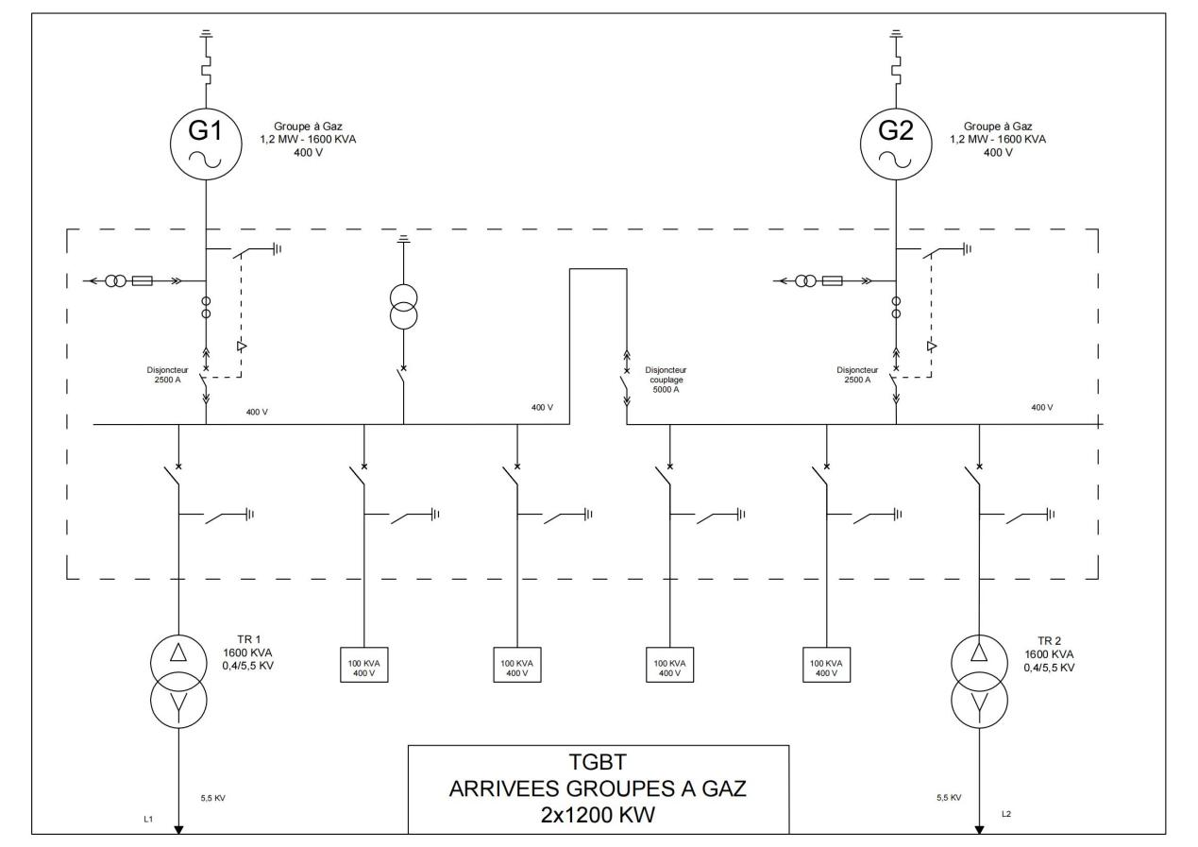
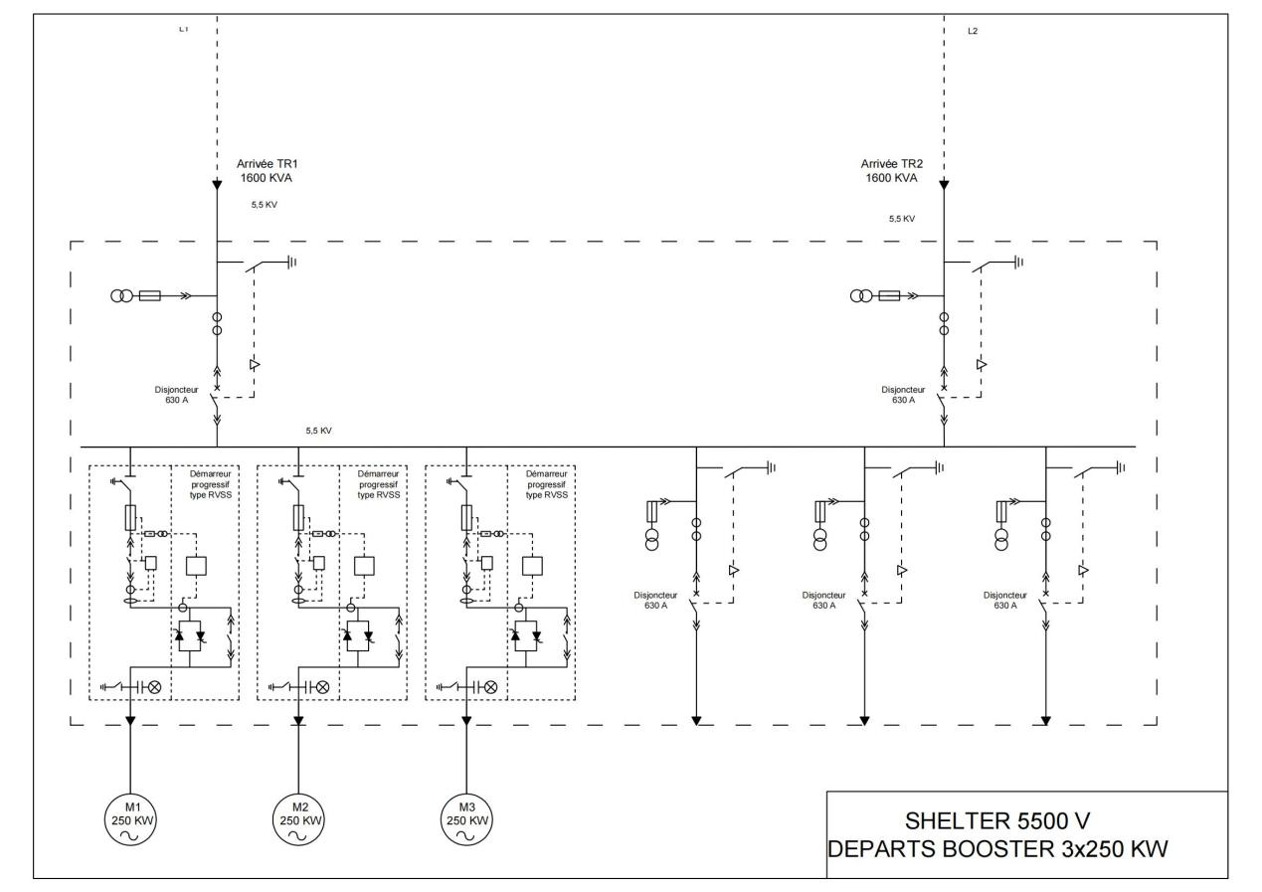

环境条件对燃气发电机组的要求Environmental conditions for gas generator set requirements
发电机组設計條件
2000 kWel; 10500 V, 50 Hz; 天然气, 甲烷值 = 80
空氣進氣溫度 / 相對濕度: [°C] / [%] 35 / 60
海拔高度: [m] 100
尾氣冷卻至: [°C] 120
NOx排放 (公差 - 8%): [mg/Nm3 @ 5% O2] 500
Design conditions for generating sets
2000 kWel; 10500 V, 50 Hz; Natural gas, methane = 80
Air inlet temperature/relative humidity: [°C] / [%] 35/60
Altitude: [M] 100
Exhaust gas cooled to: [°C] 120
NOx emission (tolerance -8%): [mg/Nm3 @ 5% O2] 500

空氣進氣溫度 [°C] 35 40 45 50 55
負荷: [%] 100 97 89 78.6 57.5
發電功率 COP: [kW] 2000 1937 1779 1573 1150
中冷水溫度 進口 / 出口: [°C] 40 45 50 55 60
air inlet temperature [°C] 35 40 45 50 55
Load: [%] 88.7 82.5 100 97 94
Medium cold water temperature inlet/outlet: [°C] 40 45 50 55 60

1.由于,现场环境温度-5--55℃,对发电机组的影响 ,要求进气温度10--40°C,中冷水温度10--45℃.Due to the on-site ambient temperature -5--55℃, the impact on the generator set, the intake temperature is required:10--40°C, medium cold water temperature;10--45 ℃.

采用箱式发电机组:
-防护阳光直射,箱板为隔热嗝音防护层.
-封闭式水散热器,适合沙漠使用.
-散热通风机,通风口设罝沙过滤罩.
-箱内制冷/制热空调机,对发电机组和变压器调节温度10-40℃.
Box type generator set:
- Protection from direct sunlight, heat insulation belch protection layer for box board.
- Enclosed water radiator, suitable for desert use.
- Heat dissipation fan, air vent with sand filter cover.
- The refrigeration/heating air conditioner in the box can adjust the temperature of the generator set and transformer to 10-40℃.

2.内燃机发电机组为实现当地环保的要求，需注意的部分 In order to meet the requirements of local environmental protection, the internal combustion engine generator set should pay attention to the following parts
发电机组NOX排放为≤500mg/Nm3.
NOX emission of the generator set is less than or equal to 500mg/Nm3.

- 噪音要求：发电机组噪音见表，箱式隔音降低后,噪音:65-75db(A).满足当地环保要求。 Noise requirements: The noise of the generator set is shown in the table. After the box type sound insulation is reduced, the noise is 65-75DB (A). Meet local environmental requirements.

頻帶  f [Hz] | 25 | 31,5 | 40 | 50 | 63 | 80 | 100 | 125 | 160 | 200 | 250 | 315 | 400 | 500 | 630 | 800 | 1k | 1.25k | 1.6k | 2k | 2.5k | 3.15k | 4k | 5k | 6.3k | 8k | 10k | 12.5k | 16k | LWA [dB(A)] | S  [m2]
空氣進氣噪聲 4)  LW,Terz [dB(lin)] | 94,9 | 96,9 | 98,0 | 100,0 | 106,3 | 111,3 | 111,7 | 118,9 | 113,6 | 116,3 | 116,8 | 112,2 | 111,6 | 114,2 | 111,5 | 111,1 | 112,2 | 110,5 | 111,3 | 111,4 | 109,2 | 107,2 | 105,7 | 105,9 | 109,4 | 120,3 | 104,7 | 99,1 | 98,6 | 123,8 ±4dB(A) | 140
尾氣噪聲 5)  LW,Terz [dB(lin)] | 118,6 | 117,9 | 121,4 | 127,3 | 126,9 | 126,8 | 126,5 | 140,9 | 126,3 | 129,9 | 130,9 | 125,2 | 126,3 | 126,5 | 125,9 | 125,9 | 125,0 | 123,3 | 123,9 | 123,8 | 123,2 | 126,3 | 116,4 | 115,5 | 115,2 | 114,1 | 114,6 | 112,6 | 110,8 | 135,8 ±3dB(A) | 15,55)

应急柴油机发电机组供应电源,要求：三相电压400V±5%，功率;200KW,频率：50±2HZ。
电源,要求：三相电压400V±5%，功率;120KW,频率：50±2HZ。
Isolated island operation emergency power supply: considering isolated island operation, it is necessary to configure an emergency diesel generator set to supply power. Requirements: three-phase voltage 400V±5%, power; 120KW, frequency: 50±2HZ.

6、燃气系统要求 Gas system requirements
发电机组对天然气的要求如下：The requirements of internal combustion engine generator set for natural gas are as follows:
燃气压力：20mbar~200mbar
燃气温度：10~50℃
气体压力波动：±10%设定压力
波动频率：≤10次/h
甲烷（CH4） 含量：最小80 典型 90.6 最大98
乙烷（C2H6） 含量：最小0 典型 3 最大10.3
丙烷（C3H8） 含量：最小0 典型 1.6 最大2
丁烷（C4H10） 含量：最小0 典型 0.5 最大0.7
戊烷（C5H12） 含量：最小0 典型 0.1 最大0.15
氮气（N2） 含量：最小0 典型 3.7 最大11
二氧化碳（CO2）含量：最小0 典型 0.5 最大2

Gas pressure: 20mbar ~ 200mbar
Gas temperature: 10 ~ 50 ℃
Gas pressure fluctuation: ± 10% set pressure
Fluctuation frequency: ≤ 10 times / h
Methane (CH4) content: minimum 80, typical 90.6, maximum 98
Ethane (C2H6) content: minimum 0, typical 3, maximum 10.3
Propane (C3H8) content: minimum 0 typical 1.6 maximum 2
Butane (C4H10) content: minimum 0, typical 0.5, maximum 0.7
Pentane (C5H12) content: minimum 0, typical 0.1, maximum 0.15
Nitrogen (N2) content: minimum 0 typical 3.7 maximum 11
Carbon dioxide (CO2) content: minimum 0, typical 0.5, maximum 2

7.燃气发电机确定 Determine for gas generator
综合各因素:
-天气;高温55 ℃,低温-5 ℃.
-沙暴:气压低.
-沙尘:零件易磨埙.
-启动电机负载波动大.
-燃气品质不稳定.
Comprehensive factors:
- the weather; 5 ℃ high, minus -5 ℃.
- Sandstorm: Low pressure.
- Dust: Parts wear easily.
- Load fluctuation of starter moto
- Gas quality is unstable.
配置大容量冷却水散热器,油/水冷却器,水泵,电加热器,冷热空调机,总功率200KW.Equipped with large capacity cooling water radiator, oil/water cooler, water pump, electric heater, cold and hot air conditioner, total power of 200KW.
A.250kw*3台=750KW,直接启动短时3倍突加功率:2250KW,稳定功率:750KW.
- 辅助功率:200KW.
合计2450kw,选择单机额定功率2000KW,130%短时功率2600KW.
配置箱式调温降压变压器:10.5KV/5.5KV(1600KVA)/0.4kv(250KVA).
数量各二台,一用一备.
A. 250KW *3 sets*3 =2250KW, direct start short-time triple surge power :2250KW, stable power :750KW.
B. Auxiliary power :200KW.
Total 2450kW, choose single rated power 2000KW,130% short-time power 2600KW.
Equipped with box type temperature regulating step-down transformers: 10.5kV / 5.5kV (1600KVA)/ 0.4kV (250KVA).
The quantity is two sets, one for use and one for standby.

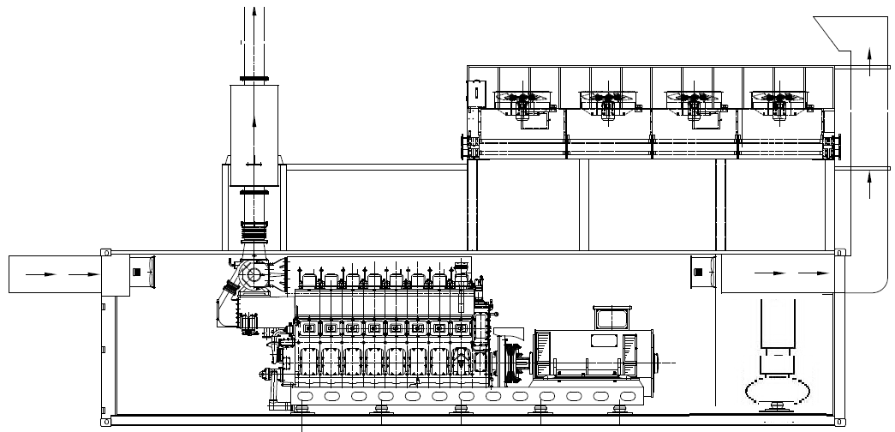

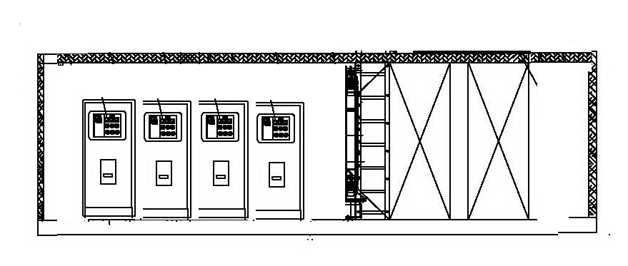
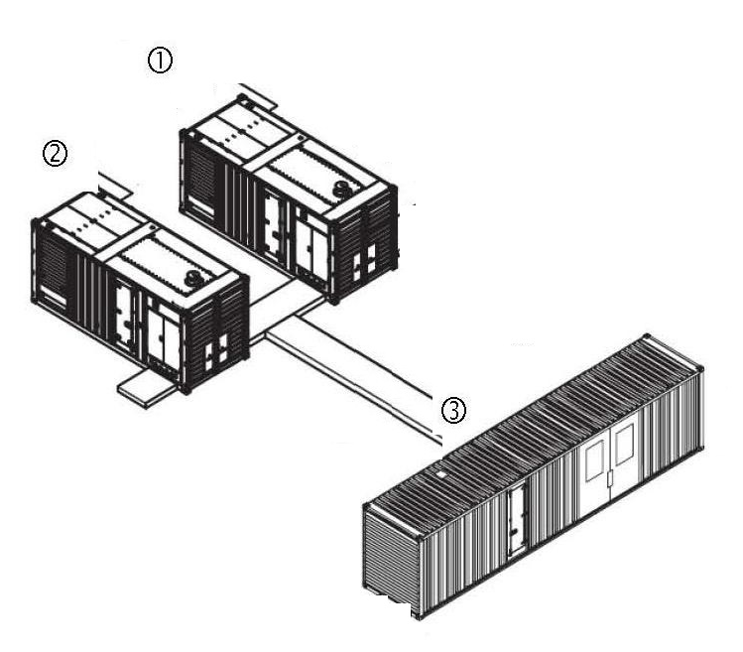
二台箱式燃气发电组并列布置,其中,一个箱内,安装一台120kw应急柴油发电机组.横向布置一台电气柜,安装变压器和电气柜.均采用冷热空调机控制温度.
Two box-type gas generator sets are arranged side by side. In one box, one set 120KW emergency diesel generator set is installed.
Horizontal arrangement of electrical cabinets, installation of two transformers and gensets unit electrical cabinets, using cold and hot air conditioning control temperature.

第三章、技术要求及规格 Chapter 3 technical requirements and specifications

3.1技术数据总览 Overview of technical data

3.1.1机组的技术数据Technical data of the genset
设计条件Design conditions
进气温度/空气湿度Intake air temperature / air humidity | °C / % | 40 / 60
安装高度 Installation height | m | <1000
NO_{x} 排放 NO_{x} emission | mg/Nm³@ 5% O₂ | 500
燃气数据(*) Combustion gas data(*)
燃气 Combustion gas | 天然气 Natural gas
甲烷值 Methane number |  | >80
低热值 Lower heat value | kWh/Nm³ | 9.34
燃气密度 Gas density | kg/Nm³ | 0.76
机组 Genset
发动机 Engine | CG170-20
发电机 Generator | AVK
电压 /电压范围  Voltage/voltage range | V  / % | 10500  10%
频率 Frequency | Hz | 50
操作模式 Operation mode |  | 孤岛（并联）运行Island(parallel) operation
能量平衡 Energy balance
cos j = φ = 1 / 时的输出电功率Electrical terminal power at cos φ = 1 / ind./overexcited | kW | 2000
冷却水热量 (± 8%)  Cooling water heat (± 8%) | kW | 840
低温混合冷却器热量 (± 8%)  NT mixture cooler heat (± 8%) | kW | 130
润滑油热量 (± 8%)  Lube oil heat (± 8%) | kW | 240
燃气总量 (+ 5%)  Fuel use (+ 5%) | kW | 4769
电效率  Electrical efficiency | % | 41.9
*客户方的燃气压力必须符合我方供货范围内的燃气控制系统所允许的入口压力。
The customer's gas pressure must correspond to the permissible inlet pressure of the gas train(s) in our scope of delivery. See technical description Fuel system.
传热的发动机冷却回路Engine cooling circuit heat exchanger
型号 Type | 冷却塔/台式散热器 Cooling tower/Radiator
体积流量 Volumetric flow rate | m³/h | 65
功率 Power | kW | 1080

传热的混合冷却回路Mixture cooling circuit heat exchanger
型号Type | 冷却塔/台式散热器  Cooling tower/Radiator
体积流量Volumetric flow rate | m³/h | 40
功率 Thermal Heat | kW | 150

冷却水管道和仪表流程图Schematic Process Flow Chart
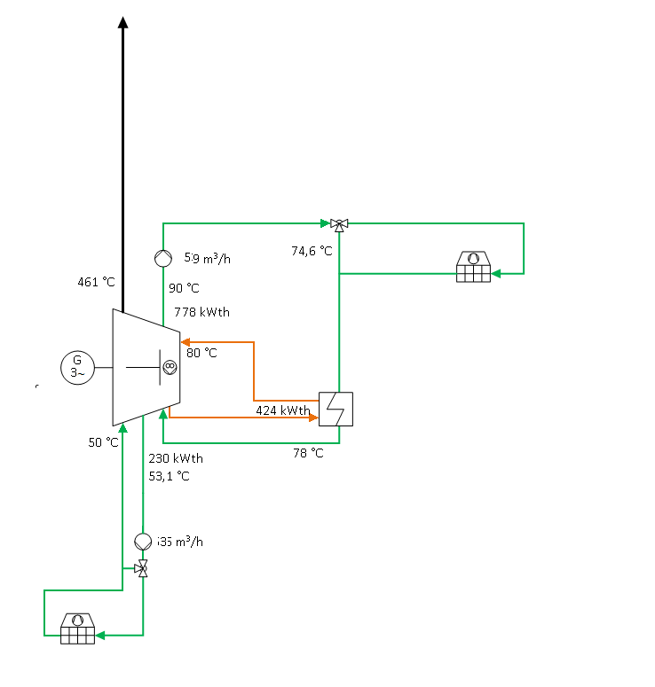
机组 Genset
燃气发动机和发电机采用弹性连接，安装在共同的机座上，通过弹簧元件安装在合适的地基上以隔离振动。
The gas engine and alternator are elastically coupled and built onto a shared base frame, enabling a sprung vibration-insulated installation on a suitable on-site foundation.

燃料供给 / 混合气处理 Fuel supply / Mixture treatment
多燃气混合器，控制每个气缸座的燃气空气混合比例。
节流装置（旁通气道），利用伺服电机来控制转速和功率。
由 TEM 系统控制的混合器伺服电机上的空气燃气混合气电子调节和监控，监控燃烧室温度（每个气缸一个温度探头）。
Multi-gas mixer for dosage of the gas-air mixture for each cylinder bank.
Throttle organ (rotary valve) with electric actuator for the speed and power control.
Electronic control and monitoring of the air-gas mixture at the mixer-actuator via combustion chamber temperature (1 temperature sensor per cylinder) with the TEM system.
空气滤清器 Air filter
干燥空气滤清器套件，每个气缸排一个，滤盒规格，散装到货。
Dry air filter packages for each cylinder series, in cassette design, supplied as loose parts.

接口 Connections
与设备管路间的接口，用于断开振动传递
Connection to the plant's lines for vibration decoupling
冷却水： 带配对法兰的橡胶补偿器
润滑油： 带配对法兰的橡胶补偿器
废气出口： 带配对法兰的不锈钢补偿器
气体燃料入口： 带配对法兰的不锈钢补偿器
Cooling water: Rubber expansion joints with counterflange
Lube oil: Rubber expansion joints with counterflange
Exhaust outlet: Stainless steel expansion joints with counterflange
Fuel gas outlet: Stainless steel expansion joints with counterflange

混合冷却系统 Mixture cooling system
两级混合冷却器，具有高效传热、低压力损失和低污垢积聚率。耐腐蚀不锈钢板条在低温水平。
2-stage mixture cooler with a highly efficient heat transfer with low pressure loss and low probability of dirt accumulation. Corrosion-resistant stainless steel slats in the low-temperature level.

防腐 Corrosion protection
对发动机和机组进行防腐处理能有效防止运输途中以及随后在目的地可能需要存放时出现锈蚀；最大防腐有效期为出厂发货后24个月，前提条件是存放在干燥封闭室内。
Corrosion protection of the engine or genset for protection during transportation and any subsequent storage at the place of destination; maximum length of protection of 24 months after delivery, when stored in closed dry room.

3.2三相交流旋转磁极式同步发电机Three phase AC rotating pole synchronous generator

Three-phase internal-pole synchronous Generator
型号： AVK Type: AVR

电压： 10500V Voltage: 10500 V

频率： 50 Hz Frequency: 50 Hz

三相同步发电机，凸极式旋转磁极发电机，无刷，自励磁，阻尼绕组，星形接点可拆解，带湿热绝缘保护（最大空气湿度 90 %)。
Three-phase synchronous generator, salient-pole machine, brushless, self-excited, with damper cage, star point dissolvable, with insulation suitable for tropical and humid ambient conditions (max. 90 % humidity).

总体结构 General structure
发电机由下列结构组成：一台旋转磁极式主发电机、一台旋转电枢式励磁机，以及一台带功率输出级的电压调节器。
励磁定子的馈电来自电压调节器。励磁转子中产生的三相交流电压通过旋转的二极管桥整流后，输送给主发电机的励磁绕组。岛式运行交流负荷下，主发电机的电压平衡，以及规定功率因数的设置或电网并联运行下无功功率的设置，均通过电压调节器中的功率调节器促使励磁电流变化来保持。
The generator comprises the main generator as internal-pole machine, an exciter as external-pole machine and a voltage controller with a power output stage。
The power of the exciter stator is supplied by the voltage controller. The three-phase alternating voltage which is induced in the exciter rotor is rectified by the rotating diode bridge and is then supplied to the field winding of the main generator. The voltage stabilization of the main generator under variable load in island mode and the setting of a specified power factor or the specified reactive power in mains parallel mode is performed by changing the field current via the power actuator in the voltage controller.

防护等级和通风Protection type and ventilation
通风方式 IC 01，符合 IEC 60034-6 标准，自然冷却循环，采用转子轴自带风扇冷却，防护等级 IP23，符合 IEC 60034-5 标准 。
Type of ventilation IC 01 acc. to IEC 60034-6 open cooling circuit with self-ventilation and protection class IP23 acc. to IEC 60034-5.

定子 Stator
定子绕组的绝缘等级为 F级, 符合 IEC 60034-1 标准。
The insulation of the stator winding corresponds to insulation class F Temperature rise according to generator data sheet according to IEC 60034-1.

转子 Rotor
转子绕组的绝缘等级 符合 IEC 60034-1 标准。
转子采用半滑键，依据 ISO 21940-1 标准进行动平衡。最大过速（旋转转速）符合 IEC 60034-1 标准。
The insulation of the rotor and field winding corresponds to insulation Temperature rise according to generator data sheet according to IEC 60034-1.
The rotor is balanced with half key ，according to ISO 21940-1. Max. overspeed (spin speed) according to IEC 60034-1.

绕组Winding
为了抑制谐波，发电机配备了 步进绕组。
绕组绝缘采用高级铸模树脂以及真空压力浸渍法（VPI）制成。除此之外，所有绕组还经过双组份环氧树脂处理，能有效防潮、防尘、防灰以及磨损颗粒。
To reduce the harmonics, the generator is equipped with a 5/6 pitch winding. The windings are insulated with a high-quality cast resin by using vacuum-pressure impregnation (VPI) which protects the windings from moisture, dust, ash, and abrasive particles.

轴承座 Shaft bearings
标准型发电机采用双轴承结构设计
By default the generator is designed as a double-bearing machine.

自动调节器 Voltage controller
电压额定值设置 ±10 % U_{N}。
Voltage nominal value setting ±10 % U_{N}.

标准和规定 Standards and specifications
IEC 60034-1, BS 4999-5000, NF 51-100, NF 51-111, OVE M-10, NEMA MG 1.22, ISO 8528-3

标准组件 / 部件组 Standard components / assembly groups
- 带主端子和星形接点的中央接线盒，辅助接线盒及端子排和附件
- 带电压调节功能、无功功率或移动系数调节功能的发电机调节器， 以及对于调节不可或缺的电压和电流转换器
- 绕组中带6个PT 100触头的温度监控器（3个启用，3个备用）
- 停车加热器：
- 测量或保护转换器
- Central terminal box with main terminals and star point, auxiliary terminal box with terminal strip and accessories
- Generator controller with functions for regulating the voltage, the reactive power or the shift factor, incl. the voltage and current transformers required for regulation
- Temperature monitoring with 6 PT 100 – sensors in the winding (3 x active, 3 x spare)
- Anti-condensation heating
- Current transformer

电气数据和特性 Electrical data and properties
- 电压准确度，静态额定电压的 ± 0.5
- 转速变化范围为参考转速的 + 3 %/ - 5 %，冷机和热机
- 空转电压 (Ph-Ph) 的总谐波失真 THDU (Total Harmonic Distortion) ≤ 3%
- 不平衡负荷 I_{Invers} / I_{N} ≤ 8%，符合IEC 60034-1标准
- 抗干扰能力，B 级，组 1，符合 DIN EN 55011; VDE 0875-11 标准
- 3 芯端子短路时稳态阶段的短路电流：不小于三倍的额定电流持续 5 秒
- 发电机过载能力 6 小时内持续 1 小时额定功率的 10%
- Voltage accuracy, static ± 0.5 to 1 % of the rated voltage
- Speed change + 3% / - 5 % of the rated speed, cold and warm machine
- Total harmonic distortion factor THDU (Total Harmonic Distortion) of the voltage (Ph-Ph) at no-load ≤ 3 %
- Unbalanced load I_{Inverse} / I_{N} ≤ 8 % according to IEC 60034-1
- Radio interference suppression level Class B, Group 1 according to DIN EN 55011; VDE 0875-11
- Sustained short-circuit current with a 3-pole terminal short-circuit: minimum threefold rated current for 5 s
- Generator overload capacity 10 % of rated power for 1 h within 6 h

润滑油位调节 lub-Oil level control
自动补充润滑油，采用浸入式油位监控探头来实现调节（最低/最高），以及新鲜油泵的电磁阀控制。
Automatic lube oil refilling, control using an immersion probe for oil level monitoring (min./max.) and for controlling the solenoid valves and the fresh oil pump.

冷却水预热系统 Cooling water preheating
电气冷却水和机油预热（加热功率大约 20 kW），带循环泵，安装在机组上，已完整布管，含机油细密滤清器。
Electric cooling water preheating and oil preheating (heating output approx. 20 kW) with circulation pump, mounted on the genset and completely encased, including oil fine filter.

预润滑泵 Prelubrication pump
安装在机组上的电动预润滑泵；转动三通阀即可清空发动机，以便更换润滑油。
Electrical prelubrication pump on genset; the engine can be emptied for oil change by switching a three-way valve.

机组附件 Genset additional parts
下列组件未装配在机组上，“零散”发货。
- 1套免维护钢制弹簧件，高度可调，便于根据现场地基情况调整机组位置。
- 2个电磁阀，带用于润滑油供给的连接件
- 1套软管，用于润滑油供给和排出接口
- 1个绝缘垫，用于排气补偿器
- 1个油雾分离器，用于曲轴箱排气，带内置滤芯过滤油雾蒸汽和连接至发动机的回流装置
- 1个负压调节器，用于安装在油雾分离器上
- 1套装配件，用于安装油雾分离器
Additional components are delivered "loose" and are not mounted on the genset.
The following componentes are delivered with the aggregate:

- 1 set of maintenance-free steel spring elements with height adjustment for easy alignment of the genset on the on-site foundation.
- 2 solenoid valves with connection parts for lube oil inlet
- 1 set of flexible hoses for lube oil inlet and outlet connections
- 1 insulation mat for exhaust expansion joint
- 1 oil separator for ventilation of the crankcase with integrated filtering of the oil mist vapors and recirculation to the engine
- 1 vacuum regulator for mounting on the oil separator
- 1 set of assembly parts for installing the oil separator

漆层Paintwork
根据工业标准组装完成后的机组漆层由以下部分组成：
- 底漆，干层厚度 40⁺³⁰ µm
- 面漆，色号 RAL 5010，黄色，干层厚度 90⁺⁴⁰ µm
- 1 罐修补漆，散装，与面漆色号相同。
According to industrial standards, paintwork of the assembled genset consists of:
- Primer, dry film thickness 40⁺³⁰ µm
- Topcoat in the shade RAL 5010, yellow dry film layer 90⁺⁴⁰ µm
- 1 can refinishing paint, loose in the shade of the topcoat.

标牌Labeling
机组标牌语言：英语(美国）

Language on the labeling of the genset: English (US)

采用VCI薄膜包裹的海运包装 Seaworthy packaging with VCI film
针对海运需要，本机组采用VCI薄膜塑封，并使用A2布遮挡保护。散装零配件则采用木箱包装，以便海运。
The genset is shrink-wrapped in seaworthy VCI film and packed with an A2 tarpaulin for further protection. The loose accessory parts are packed in seaworthy wooden boxes.

3.3 燃料系统 fuel system
零压燃气控制系统 Zero pressure gas control line
燃气类型： 根据燃气分析
额定宽度（出口侧）： DN 125
制造商： Dungs

Gas type: According gas composition
Nominal width (outlet side): DN 125
Manufacturer: Dungs

燃气控制系统为通过检测的功能部件组，由多个单个组件组成，符合欧盟压力设备指令和欧盟燃气设备指令的欧盟工程样品检验证书，适用于符合 DVGW G 260 的 1、2 和 3 系列气体（气态阶段）。
Gas control line as a tested functional assembly made from individual components with EC prototype test certificates in accordance with the EC pressure equipment directive and the EC gas equipment directive, suitable for gases of the gas families 1, 2 and 3 (in the gaseous phase) in accordance with DVGW G 260.
以遵守适用的制造商声明规则为前提，该燃气控制系统符合 TRBS 2152 第 2 部分，章节中规定的“技术上持久密封”设备，因此不在可导致易爆大气环境的因素之列。
Provided it complies with the regulations of the applicable manufacturer's declaration, the gas control line is deemed to be "permanently technically sealed" in accordance with TRBS 2152 Part 2, and can thus be excluded as the cause of an explosive atmosphere.

- 1 个球阀 1 ball valve
- 1 个燃气过滤器 1 gas filter
- 1 个压力表 1 manometer
- 1 压力监测器，用于监测最低燃气压力1 pressure monitor for minimum gas pressure
- 2 个自动截止阀，阀门等级 A，组别 2
2 automatic shut-off valves, valve class A, group 2
- 1 个零压调节器 1 zero pressure controller
- 1 个出口铸件，用于连接零压调节器的外部测量位置
1 outlet molding in the case of external measuring point of the zero pressure controller

- 2 个配对法兰，用于在燃气管道中安装燃气控制系统
2 counterflanges for installation of the gas control line in the gas line
该燃气控制系统的设计入口压力为 150 mbar，允许误差 AC 10，压力波动频率 < 10/h。为确保出口压力调节的准确度，入口压力允许的最大值为 200 mbar。出口压力（OPd）为 0 mbar +/- 3 mbar。
The gas control line is designed for an inlet pressure of 150 mbar with a permissible accuracy of AC 10 with a pressure fluctuation frequency < 10/ h. To secure the control accuracy of the outlet pressure, the maximum permissible inlet pressure is 200 mbar. The outlet pressure (OPd) is 0 mbar +/-3 mbar.
根据燃气种类和运行模式，燃气控制系统的配置可能有所不同。以订货时另外创建的零件清单为准。

The equipment of the gas control line may vary depending on the gas or operation type. The bill of materials separately created at order is binding.

钢制补偿器 Steel expansion joint
钢制补偿器，用于燃气管与燃气空气混合器之间的挠性连接，带配对法兰
额定宽度： DN 125
Steel expansion joint for flexible connection of the gas line to the gas-air mixer, incl. counterflange
Nominal width: DN 125

3.4 混合冷却回路 Mixture cooling circuit

三通阀 3-way valve
带伺服驱动的三通调节阀，阀门可以用作分配或混合阀。壳体由 EN-GJL-250 制成，3 通形式，螺纹由 1.4021 制成。 电动线性驱动装置，5 kN，防护等级 IP 65，机械式行程显示器，手动应急调节装置。
连接法兰 DN 80 / PN 16
电动机电压 24 V
Three-way control valve with actuator, valve can be used as a diverting or mixing valve. Housing made of EN-GJL-250, 3-way form, spindle made of 1.4021. , 5 kN, protection type IP 65, mechanical stroke indicator, manual emergency adjustment.

Connection flanges DN 80 / PN 16
Motor voltage/frequency 24 V

台式冷却器下游的温度传感器 Temperature sensor after radiator
温度传感器（PT 100，带发送器），带单独的旋入保护套，材质不锈钢，接头盖上带固定夹，护管材质为不锈钢。
工作电压： 8 至 35 VDC
测量范围： 0 至 200 °C
输出端（恒流）： 4 至 20 mA
安装长度 120 毫米
Temperature sensor (PT 100 with transmitter) with separate threaded protective sleeve made of stainless steel, cover on the connection head with clip fastening, neck pipe made of stainless steel.

Operating voltage 8 to 35 VDC
Measuring range 0 to 200 °C
Outlet signal 4 to 20 mA
Installation length 120 mm

安全阀 Safety valve
膜片式安全阀，配有与膜片分离的先导密封垫。
最大热功率，直接加热 395 kW
过压阈值： 3.00 bar
Diaphragm safety valve with upstream sealing gasket that is separated from the diaphragm.

Max. heat output, directly heated 395 kW
Opening overpressure: 3.00 bar

缺水保险装置 Low water safety device
水位限制器，配备玻璃浮子，根据水位变化通过电磁感应操动微开关。
最大工作超压 10 bar
最大工作温度 120 °C
安装位置 垂直主轴
Water level limiter with glass float and with magnetic transfer of the float movement to a microswitch.
Max. operating overpressure 10 bar
Max. operating temperature 120 °C
Installation position main axis vertical

排气阀 Vent valve
用黄铜冲压而成的浮筒排气阀，带完全密封的截止装置和附属的截止阀。
最高温度 120 °C
最高压力 10 bar
Float vent in pressed brass design, with ready sealed shut-off device and corresponding shut-off valve.
Maximum temperature 120 °C
Maximum pressure 10 bar

用户保障流通的压差监测器 Differential pressure monitor for flow monitoring

压差测量和开关设备带有坚固的测量仪和减震器，测量元件由表面经过处理的钢 1.4310 制成，带微型开关。
最大静态工作压力 16 bar
Æ 压力接口（卡套式管接头） 12 mm
测量范围 0-2,5 bar

Differential pressure measuring and switching device with robust measuring system and damping reactor, measuring elements made of surface-treated steel 1.4310, with microswitch.
max. operating pressure 16 bar
pressure connection (cutting ring screw joint) 12 mm
measuring range 0-2,5 bar

3.5发动机冷却回路 Engine cooling circuit

润滑油热交换器Lube oil heat exchanger
借助片式热交换器将润滑油热量传输到冷却回路。片式热交换器采用螺丝拧紧结构，并采用可优化流动的片式设计，接头带有法兰。
With the help of a plate heat exchanger, the lube oil heat is transmitted to a cooling circuit. Plate heat exchanger in screwed construction with flow-optimized plate design, connections with flanges.

热功率 | kW | 424
 |  | 润滑油 | 冷却水
入口温度 | °C | 88 | 75
出口温度 | °C | 80 | 78
体积流量 | m³/h | 71 m³/h | 62

Heat output | kW | 424
 |  | Lube oil | Cooling water
Inlet temperature | °C | 88 | 75
Outlet temperature | °C | 80 | 78
Flow rate | m³/h | 71 m³/h | 62

三通阀 3-way valve
带伺服驱动的三通调节阀，阀门可以用作分配或混合阀。3 通形式， 电动线性驱动装置，5 kN，防护等级 IP 65，机械式行程显示器，手动应急调节装置。
连接法兰 DN 125 / PN 16
发动机电压 24 V

Three-way control valve with actuator, valve can be used as a diverting or mixing valve. 3-way form, 5 kN, protection type IP 65, mechanical stroke indicator, manual emergency adjustment.

Connection flanges DN 125 / PN 16
Motor voltage/frequency 24 V

润滑油热交换器上游的温度传感器 Temperature sensor before lube oil heat exchanger
温度传感器（PT 100，带发送器），带单独的旋入保护套，材质不锈钢，接头盖上带固定夹，护管材质为不锈钢。
工作电压： 8 至 35 VDC
测量范围： 0 至 200 °C
输出端（恒流）： 4 至 20 mA
安装长度 210 毫米
Temperature sensor (PT 100 with transmitter) with separate threaded protective sleeve made of stainless steel, cover on the connection head with clip fastening, neck pipe made of stainless steel.

Operating voltage 8 to 35 VDC
Measuring range 0 to 200 °C
Outlet signal 4 to 20 mA
Installation length 210 mm

冷却器下游的温度传感器 Temperature sensor after radiator
温度传感器（PT 100，带发送器），带单独的旋入保护套，材质不锈钢，接头盖上带固定夹，护管材质为不锈钢。
工作电压： 8 至 35 VDC
测量范围： 0 至 200 °C
输出端（恒流）： 4 至 20 mA
安装长度 170 毫米
Temperature sensor (PT 100 with transmitter) with separate threaded protective sleeve made of stainless steel, cover on the connection head with clip fastening, neck pipe made of stainless steel.

Operating voltage 8 to 35 VDC
Measuring range 0 to 200 °C
Outlet signal 4 to 20 mA
Installation length 170 mm

安全阀 Safety valve
膜片式安全阀，配有与膜片分离的先导密封垫。
过压阈值： 3.00 bar
Diaphragm safety valve with upstream sealing gasket that is separated from the diaphragm.
Opening overpressure: 3.00 bar

缺水保险装置 Low water safety device
水位限制器，配备玻璃浮子，根据水位变化通过电磁感应操动微开关。
最大工作超压 10 bar
最大工作温度 120 °C
安装位置 垂直主轴
Water level limiter with glass float and with magnetic transfer of the float movement to a microswitch.
Max. operating overpressure 10 bar
Max. operating temperature 120 °C
Installation position main axis vertical

排气阀 Vent valve
用黄铜冲压而成的浮筒排气阀，带完全密封的截止装置和附属的截止阀。
最高温度 120 °C
最高压力 10 bar
Float vent in pressed brass design, with ready sealed shut-off device and corresponding shut-off valve.
Maximum temperature 120 °C
Maximum pressure 10 bar

用户保障流通的压差监测器Differential pressure monitor for flow monitoring
压差测量和开关设备带有坚固的测量仪和减震器，测量元件由表面经过处理的钢 1.4310 制成，带微型开关。
最大静态工作压力 16 bar
压力接口（卡套式管接头） 12 mm
测量范围 0-2,5 bar
Differential pressure measuring and switching device with robust measuring system and damping reactor, measuring elements made of surface-treated steel 1.4310, with microswitch.
max. operating pressure 16 bar
pressure connection (cutting ring screw joint) 12 mm
measuring range 0-2,5 bar

3.5排气系统 exhaust system
排气背压监测器 Exhaust back-pressure monitor
用于监控发动机后最大允许排气背压的压力传感器。适合安装在发动机（涡轮增压机）后的排气管道中和氧化催化器或排气消音器前。
膜片式压力监测器，无硅酮，带微型开关；供货范围包括约 400 mm 长的保护管。
操作范围 mbar 5 至 500
Pressure sensor for monitoring the maximum permissible exhaust gas back pressure downstream of the engine, for installation in the exhaust line downstream of the engine (turbocharger) and upstream of the catalytic converter or exhaust silencer. Diaphragm pressure monitor with microswitch, scope of supply including approx. 400 mm protective tube.
Switching range mbar 5 to 500

3.6电气系统electrical system

发动机控制TEM-EVO系统 enginer control TEM-EVO system
全面电子化管理 (TEM) 系统可检查和监控一个单元内的燃气发动机和发动机辅助驱动装置的所有功能。通过监控功能，它可以保护发动机，避免出现不允许的极限状态，确保延长设备寿命。TEM-EVO 系统调节并优化气缸内的燃气燃烧。集成的调节功能负责对所有运行状态下的发动机值进行优化，并实现可重复性。可选项范围广，因此 TEM-EVO 系统可以根据特定应用情况进行优化调整。
The Total Electronic Management (TEM) system involves controlling and monitoring all functions of a gas engine, as well as the engine auxiliary drives in one unit. Its monitoring functions protect the engine against impermissible boundary conditions and guarantee a long service life. The TEM EVO system regulates and optimizes gas combustion in the cylinders. Integrated regulatory functions ensure optimum, reproducible engine status values in all operating conditions. Thanks to a wide range of options, the TEM EVO system can be optimally adapted to specific application cases.
TEM-EVO 系统由 3 个组件组成：
The TEM EVO system comprises 3 components:
- IO 控制器 I/O Controller
- 操作计算机Operating computer
- 机组开关柜 (“AGS”)Genset switch cabinet ("AGS")

基本功能 Basic functions
- 自动的燃气发动机机组启动和停止程序流程
- Automatic program flow for starting and stopping the gas engine genset
- 将废气排放调节到低 NOx 值
- Reliable control of exhaust emissions at low NOx values
- 集成一体的数字化转速和功率调节
- Integrated digital engine speed and power control
- 执行器和传感器连接在辅助机组开关柜中的 IO 控制器上，通过 CAN 总线或者直接传输数据至 TEM-EVO 机组柜
- Connection of actuators and sensors to the I/O Controller in the auxiliary genset cabinet and data transmission via CAN bus or directly to the TEM EVO genset cabinet
- 监控机组上的所有传感器Monitoring of all sensors in the genset
- 监控发动机冷却水Monitoring of the engine cooling water
- 控制和监控润滑油回路，并且进行机油预润滑、再润滑和换油
- Control and monitoring of the lube oil circuit, including pre- and relubrication as well as oil change
- 测试模式，用于检测相连的执行器、传感器和辅助机组
- Test mode for verification of connected actuators, sensors and auxiliary gensets
- 测量值的电子式连续自动记录仪，用于检查和诊断目的，在 40 小时/ 6 分钟的时间范围内，并与工作周期同步
- Electronic line recorder for measured values for control and diagnostic purposes over time periods of 40 h / 6 min as well as work cycle-synchronously
- 电子操作日记，用于记录警告、故障和运行信息及日期和时间，从而实现对运行情况的详细观察
- Electronic operating log to record warning, fault and operating messages with their dates and times of occurrence for detailed observation of operations
- 电子运行小时计时器，带 5 个负载范围的解码
- Electronic operating hour meter with breakdown into 5 load ranges
- 可以连接操作计算机
- Option to connect an operating computer
- MK发动机冷却水调节装置：通过控制三通阀，冷却水回路调节装置可实现最佳的冷却水温度。部分负载时，升高冷却水入口温度。
- [MK] Engine cooling water control: the cooling water circulation control actuates a three-way valve to ensure an optimum cooling water temperature. At partial load, the cooling water inlet temperature is increased.
- [GK] 混合冷却回路：通过控制混合冷却水回路中的调节阀来调节混合冷却水入口温度；监控接收器温度
- [GK] Mixture cooling circuit: controls the mixture cooling water outlet temperature by actuating a control valve in the mixture cooling water circuit; monitors the receiver temperature

- [IOC] IO 控制器：通过 IO 控制器控制辅助机组、泵、阀门等，并采集相应的测量值。IO 控制器零散供货，用于安装在辅助机组开关柜中
- [IOC] I/O Controller: the auxiliary gensets, pumps, valves, etc. are controlled and the associated measured values are recorded via the I/O Controller. The I/O Controller will be delivered loose for installation in the auxiliary genset switch cabinet
- 可参数化的消息：利用范围广泛的参数化选项设置数字输入端，以将设备特定的故障、警告或消息直接放到 TEM-EVO 系统。从而大大简化机组监控，并且通过操作日记中的记录功能实现透明监控。可参数化的消息作为无电位触点被放到 TEM 辅助机组开关柜内的 IO 控制器上。
- parameterizable messages: digital inputs with comprehensive options for parameterization to allow the connection of plant-specific faults, warnings or messages directly to the TEM EVO system. This greatly simplifies genset monitoring and makes it transparent due to the logging function in the operating log. The parameterizable messages are issued as potential-free contacts in the TEM auxiliary genset switch cabinet on the I/O Controller.
- [SER] 用于数据交换的串行连接：通过串行连接与上一级控制系统交换数据，例如额定值、测量值、消息、警告和故障，借助协议 3964R 及 RK512，通过 TTY 或 CS 20mA。TEM-EVO 和上一级控制系统之间最长的电缆长度为 100m。
- [SER] Serial coupling for data exchange: exchange of data such as e.g. set values, measured values, messages, warnings and faults with the superior control via serial coupling by means of protocol 3964R with RK512 via TTY or CS 20 mA. The maximum cable length between the TEM EVO and the superior control is 100 m.
- [AKRK] 抗爆调节装置：高动态抗爆调节装置针对每个气缸进行单独调节——即使甲烷值低也能保证发动机可靠运行。在遵守排放极限值的前提下，以最佳效率实现最大可能的功率
- [AKRK] Anti-knock control: individual highly dynamic anti-knock control for each cylinder – for safe operation of the engine even at a low methane number. Best possible performance and efficiency and observance of the emission limit values
- [GL] 监控发电机轴承温度：显示（界面、历史、串行连接）和监控两个发电机轴承温度。超出可参数化的极限值时，会触发一个故障或警告
- [GL] Monitoring of the generator bearing temperatures: display (mask, history, serial coupling) and monitoring of the two generator bearing temperatures. A fault or warning is triggered when a parameterizable limit value is exceeded.
- [GLT] 为了保护发动机，在 TEM-EVO 中探测并监控基础轴承温度（主发动机轴承温度）。超出极限值时，分别根据超出程度，至少触发一个警告和一个故障
- [GLT] The basic bearing temperature (main engine bearing temperature) is recorded and monitored in the TEM EVO to protect the engine. If the threshold value is exceeded, depending on the magnitude of the exceedance, a warning is triggered first and then a fault。
- [SATL2] 测量和限制废气涡轮增压器转速：显示（界面、历史、串行连接）和限制废气涡轮增压器转速
- [SATL2] Measurement and restriction of the exhaust gas turbocharger rotational speeds: display (mask, history, serial coupling) and restriction of the exhaust gas turbocharger rotational speeds
- [NATL2] 动态监控废气涡轮增压器 A 和 B 后的废气温度：显示（界面、历史、串行连接）和动态监控废气涡轮增压器后的废气温度。超出可参数化的极限值时，会触发一个故障
- [NATL2] Rolling monitoring of the exhaust gas temperature after turbocharger A and B: display (mask, history, serial coupling) and rolling monitoring of the exhaust gas temperature after the turbocharger. A fault is triggered when a parameterizable limit value is exceeded

- [BSX], [BSXK] eService 系统预先装备 [BSX]，带电缆组 [BSXK]：用于远程操作 TEM-EVO 的预先装备 (BSX)：需要用于要连接在 eService 调制解调器系统、机械转换器或智能选择单元 (IAE) 上的每个 TEM-EVO
- [BSX], [BSXK] Pre-fitment for eService system [BSX] with cable harness [BSXK]: Pre-fitment for remote control of the TEM EVO (BSX): required for each TEM EVO that is to be connected to an eService modem system, a mechanical switch or an intelligent selection unit (IAE)
- [VAWT/VSWT] 测量废气热交换器前和润滑油热交换器前的加热水温度
- [VAWT/VSWT] Measurement of heating water temperature before the exhaust heat exchanger and before the lube oil heat exchanger
- [2xNKAT] 为了保护催化转换器，在 TEM-EVO 中测量催化转换器后的废气温度，并根据情况监控工作点。超出可参数化的极限值时，会触发一个故障
- [2xNKAT] To protect the catalytic converter, in the TEM EVO the exhaust gas temperature is measured after the catalytic converter and the operating point is dependently monitored. A fault is triggered if the parameterizable threshold value is exceeded
- [AWG32] 控制废气排气门，测量调节阀位置并控制伺服电机
- [AWG32] Activation of the exhaust gas wastegate, measurement of the position of the control device and operation of the actuator

扩展功能Extended functions

- [TKS] 台式冷却器控制系统，用于每个回路带一个冷却器的混合冷却和发动机冷却回路或紧急冷却回路，可以通过参数设置为根据排风机档位进行切换（最多 17 档），或者针对频率可调的排风机进行参数设置
- [TKS] Table cooler control for mixture cooling and engine cooling circuit or emergency cooling circuit with one cooler per circuit, parameterizable as a fan level switch (maximum 17 levels) for frequency-controlled fans

- [MTCP] 以太网 TCP/IP：以太网 TCP/IP 现场总线接口，用于采用 Modbus/TCP 协议的通信。通过接口可检索 TEM-EVO 中的状态信息、测量值、消息、警告、故障，并且可以将额定值或命令发送到 TEM-EVO（取代基本系统中包含的 SER 选件而安装 MTCP）。
- [MTCP] Ethernet TCP/IP: field bus interface Ethernet TCP/IP for communication with protocol Modbus/TCP. Via the interface, status information, measured values, messages, warnings, faults from TEM EVO are available for retrieval and set values or commands can be sent to the TEM EVO (MTCP is installed instead of the SER option contained in the basic system).

IO 控制器 I/O Controller
用于安装在辅助机组开关柜中（用带屏蔽的三芯总线线缆布线）
For installation in the auxiliary genset switch cabinet (cabling with shielded three-core bus cable).

操作计算机 Operating computer
操作计算机 BRT 用于操作 TEM-EVO 系统。其设计用于安装在封闭的开关柜中。15“ TFT 显示屏的触摸功能以及图形操作界面可以实现简单、直观的操作。

机组开关柜直接安装在机组旁边。组合在工厂通过检测的发动机电缆，连接在机组开关柜上且通过检测的机组电缆（机组上通过插塞连接器相连）可确保正常运行和高运行安全性。
涉及功率部件的信号直接在辅助机组开关柜内通过 IO 控制器与 TEM-EVO 系统之间进行交换。数据通过准确无误的 CAN 总线连接传输至机组控制系统。
The operating computer BRT is used to operate the TEM EVO system. It is intended to be installed in the closed switch cabinet. The touch functionality of the 15" TFT monitor and the graphic user interface allow easy and intuitive operation.

The genset switch cabinet is situated in the direct vicinity of the genset. Together with the factory-tested engine cabling, the cables fitted and tested on the genset switch cabinet and connected to the genset (with plug connections on the genset) ensure smooth commissioning and a high level of operational reliability.
Signals relating to the power part are exchanged directly with the TEM EVO system in the auxiliary genset switch cabinet via the I/O Controller. Data is transmitted to the genset control via an extremely fail-safe CAN bus connection.

操作 Operation
可以访问所有功能的智能操作计算机可确保轻松操作 TEM-EVO 系统。操作计算机装备有 15“-TFT 触摸显示屏。操作计算机的触摸功能可实现简单且直观的机组操作。操作人员用导航栏可以快速且直接地进行界面切换，以操作机组。每个操作计算机界面都会为操作人员提供有关已连接机组的状态信息。只需短短的培训，即可操作所有调节、服务、控制和监控功能。
TEM-EVO 中保存有多种语言，用户可以使用其中一种进行操作。通过按下按钮可以随时快速地切换语言。在进行服务时，可暂时将另一种语言设置为设备操作人员使用的语言。
Easy operation of the TEM EVO system is ensured by an intelligent operating computer that can be used to access all functions. The operating computer is equipped with a 15" TFT touch monitor. The touch function of the operating computer allows easy and intuitive operation of the genset. The operator can use the navigation bar to quickly and directly change a screen to operate the genset. Each operating computer screen informs the operator about the status of the connected genset. All regulation, service, control and monitoring functions can be operated conveniently without a lengthy training period.
Communication with the user can take place in one of the many languages that can be stored in the TEM EVO. The language can be changed quickly at any time by pressing a button. Service work may be temporarily performed in a different language to that used by the site staff.

操作日记 Operating log
在 TEM-EVO 系统的电子操作日志中，将完整记录机组运行中规定的故障信息、警告信息和文本信息。通过过滤器可有针对性地显示信息组。
所有运行信息和影响运行的切换操作以及每一次的参数更改都使用精确的时间戳（日期/时间）记录。
TEM-EVO 系统一共可监控和区别超过 600 个不同的事件。以此对机组（包括由 TEM EVO 控制的辅助功能）的运行方式进行快速和详细的分析。
Operation of the genset is seamlessly logged via defined fault, warning and text messages in the electronic operation log of the TEM EVO system. By means of filters, groups of information can be presented in a well-directed way.
All operating messages and operationally-relevant switching actions are recorded with a precise time stamp (date/time), as are all parameter changes.
As a whole, the TEM EVO system can monitor and distinguish between over 600 different events. This makes it possible to provide fast and detailed analyses of genset operating modes, including TEM EVO-controlled auxiliary functions.

历史History
历史功能可以记录最多 84 个测量值。在图表中同时可以显示最多 18 条测量值曲线。用户可以自行排列测量值曲线。TEM-EVO 系统以三种速度级记录历史：
工作循环历史：记录每个工作循环的当前值（1 个工作循环相当于 2 次曲轴转动）
6 分钟历史：记录每秒的当前值
40 小时历史：记录 6 分钟平均值

可通过光标在曲线上移动，然后相应的测量值以数值形式连同具体的时间戳一起显示出来。有故障时，为了使故障诊断更容易，记录将在 40 秒后自动停止。通过“Realtimescope”功能可以连续观察测量值和调节功能。
为了继续进行分析，可选择性地对这些测量值进行存储并在日后重新读取。
The history function records up to 84 measured values. Up to 18 measured value curves can be displayed together in a single diagram. The user can compile the measured value curves themselves. The TEM EVO system records the history in three speed levels:
- Working cycle history: records actual values in each working cycle
- (1 working cycle corresponds to 2 crankshaft revolutions)
- 6 min. history: records current values at one second intervals
- 40 h history: records 6 min. average values

The graphs can be traced with the cursor, wherein each measurement value is indicated as a number with a precise time stamp. If a fault occurs, logging stops automatically after 40 s in order to facilitate fault diagnosis. The function "Real time scope" allows continuous observation of measured values and regulatory functions.
Optionally, measurements can be saved and retrieved later for further analysis.
诊断/服务功能 Diagnosis / service functions
除了历史和操作日记外，TEM-EVO 系统还有其他诊断和服务功能，其主要用于实现燃气发动机模块的高可用性。通过这些功能也可大大简化并加速调试过程。这是提高燃气发动机模块整体经济性的重要因素。
In addition to the history and operating log, the TEM EVO system contains additional diagnosis and service functions which contribute significantly to the high availability of the gas-engine module. Commissioning also becomes easier and faster using these functions. This contributes decisively towards the overall economic efficiency of the gas engine module.

机组开关柜 (“AGS”)Genset switch cabinet ("AGS")
机组开关柜设计用于控制 CES 的燃气发动机。
其包括机组控制系统和通过 TÜV 检测的安全链。
The genset switch cabinet is intended for the control of CES gas engines.
It contains the genset control and the TÜV-approved security chain.

机组电缆Genset cables
连接在机组开关柜上且通过检测的机组电缆组件由 6 根预制的电缆束组成，配有不可更换的坚固插塞连接器，用于机组和 TEM-EVO 开关柜之间的连接。
Genset cable set, connected to the genset switch cabinet and tested, consisting of 6 pre-confectioned cable harnesses with robust, non-interchangeable plug connections for connection between the genset and the TEM EVO switch cabinet.

负载分配Load sharing
针对多发动机设备，孤岛并联运行下需要将有功功率分配到单个机组。
负载分配设计用于最多四个燃气机组及一个电网高压断路器。
结构：
负载分配到货时已安装在尺寸为 550 x 400 mm 的安装板上，用于装入开关柜中。安装深度为 250 mm。
负载分配需要以下周边条件：
- 允许的环境温度：0...40°C
- 工作温度：25...30°C
- 运输和存放温度：-20...70° C
- 最大相对湿度：90%（无冷凝）
With multi-engine plants, distribution of the active power to the individual gensets is necessary in island parallel mode.
The load sharing is designed for up to four gas gensets and a mains circuit breaker.
Layout:
The load sharing is delivered fully assembled on a mounting plate with the dimensions 550 x 400 mm for cabinet installation. The installation depth is 250 mm.
The following framework conditions apply to the load sharing:
- permissible ambient temperatures: 0...40 °C
- operating temperature: 25...30 °C
- transport and storage temperatures: -20...70 °C
- relative humidity: max. 90% (non-condensing)

符合机械指令的EC声明 EC Declaration according to Machinery Directive
本产品符合欧盟机械指令 2006/42/EC 规定的相关基本安全和健康要求。根据供货范围，Caterpillar Energy Solutions GmbH 会创建一份安装声明或一致性声明，作为随附技术文档的一部分。
The product meets the applicable essential health and safety requirements according to the EC Machinery Directive 2006/42/EC. Depending on the scope of supply, Caterpillar Energy Solutions GmbH draws up a Declaration of Incorporation or a Declaration of Conformity which is part of the documentation to be provided.

3.7辅助设备 Auxiliary equipment

3.7.1辅助电气设备HAS柜系统构成:Auxiliary electrical equipment has cabinet system composition:
辅助设备控制系统又称HAS柜，尺寸：1600宽×600深×2200高，配接TEM EVO接口（输入输出控制器）程序。实现对辅助设备，包括散热水箱，通风系统，以及热能利用系统的综合控制。并实现对燃机的远程控制与通讯。包含电力控制,保护。其主要电力器件采用全球著名的控制系统专家DEIF产品，电子元件均采用西门子，ABB等原厂进口元件。
Auxiliary equipment control system, also known as has cabinet, size: 1600 wide × 600 deep × 2200 high, with TEM Evo interface (I / O controller) program. Realize the comprehensive control of auxiliary equipment, including cooling water tank, ventilation system and heat utilization system. And realize the remote control and communication of gas turbine. Including power control, protection. The main power components are the world famous control system expert Deif products, and the electronic components are imported from Siemens, abb and other original factories.

机组辅助设备以及电力系统并联及保护系统功能：Unit auxiliary equipment and power system parallel and protection system function
辅助柜（HAS柜）中安装TEM EVO 系统中的操作计算机，以及通过MWM提供的I/O控制器实现对于外围根据不同用户配置的辅助设备的控制。同时安装电力管理及同期并网解列装置，由各机组集装箱中的HAS柜完成每台机组的同期并网。The operating computer of TEM Evo system is installed in the auxiliary cabinet (has cabinet), and the I / O controller provided by MWM is used to control the peripheral auxiliary equipment configured by different users. At the same time, the power management and simultaneous grid connection splitting devices are installed, and the synchronous grid connection of each unit is completed by the has cabinet in each unit container.

3.7.2辅助设备回路的控制：Control of auxiliary equipment circuit:
1）中冷器二级冷却回路散热器，散热风机采用变频控制：
变频器，接触器，保护装置，控制系统。以上系统装置在变频器柜（FUS）中，TEM EVO 系统测量散热回路的温度,控制变频器的频率增加或者减少，从而对散热器实现精确的温度控制，并达到节约能耗的功效。
2）发动机冷却水用紧急散热器，散热风机采用变频控制：
变频器，接触器，保护装置，控制系统。以上系统装置配电在变频柜中，TEM EVO 系统测量散热回路的温度, 控制变频器的频率增加或者减少，从而对散热器实现精确的温度控制，并达到节约能耗的功效。
3）通过变频器控制集装箱内进风
送风装置控制系统，利用公用的变频器
进风阀门控制系统
排风阀门控制系统
通过 TEM EVO 选项“RL”或通过 PT100 控制室内通风
4）润滑油的供应和废油处理
油箱装置高、低位传感器，控制新鲜润滑油泵的动作。
溢出保护装置（防止新鲜油箱溢出，包括预润滑泵锁定），连接TEM 辅助故障模块相连的端子排上“新鲜油不足”、“新鲜油箱溢出”信息组。
5）废气三通阀控制系统
2个活门驱动的控制系统，分别带有转矩监控和限位开关监控，同时包括 TEM 辅助故障模块的故障信息。
6）手动/自动控制开关同时用于两个阀门
7）燃气警报装置
燃气警报装置信号输入多功能控制器中，处理燃气警报装置的故障信息（等级为 1 时，所有风扇打开，发送 TEM 可设置参数信息的警告，等级为 2 时，机组紧急关闭，通过主接触器关断 400V 辅助供电，发送可设置参数信息的关闭信息）。
8）火灾警报装置信号输入多功能控制器中
9）各燃气发电机组集装箱内全部火灾报警信号、甲烷浓度报警信号均接入集装箱的HAS柜中，打开和关闭风阀、通风机及解列停机等自动控制由HAS柜完成，HAS柜留出一个干接点信号，安装控制集装箱内的火灾自动报警控制器，用于控制集装箱内了解燃气发电机组集装箱内的是否有报警信号动作。
处理火灾警报装置的故障信息（等级为 1 时，所有风扇打开，发送 TEM 可设置参数信息的警告，等级为2时，机组紧急关闭，通过主接触器关断 400V 辅助供电，发送可设置参数信息的关闭信息）。
1) The secondary cooling circuit radiator and cooling fan of intercooler are controlled by frequency conversion
Inverter, contactor, protection device, control system. The above system is installed in the frequency converter cabinet (FUS). TEM Evo system measures the temperature of the cooling circuit and controls the frequency of the frequency converter to increase or decrease, so as to achieve accurate temperature control of the radiator and achieve the effect of energy saving.
2) The engine cooling water uses emergency radiator, and the cooling fan adopts frequency conversion control
Inverter, contactor, protection device, control system. The above system devices are distributed in the frequency conversion cabinet. TEM Evo system measures the temperature of the cooling circuit and controls the frequency of the frequency converter to increase or decrease, so as to achieve accurate temperature control of the radiator and achieve the effect of energy saving.
3) Control the inlet air of container by frequency converter
Air supply device control system, using the common inverter
Air inlet valve control system
Exhaust valve control system
Indoor ventilation is controlled by TEM Evo option "RL" or PT100
4) Lubricating oil supply and waste oil treatment
The oil tank is equipped with high and low position sensors to control the action of fresh lubricating oil pump.
Overflow protection device (to prevent the fresh oil tank from overflowing, including the locking of the prelubrication pump) is connected to the information group of "insufficient fresh oil" and "fresh oil tank overflowing" on the terminal block connected to the TEM auxiliary fault module.
5) Control system of exhaust three way valve
The control system driven by two valves has torque monitoring and limit switch monitoring respectively, and includes fault information of TEM auxiliary fault module.
6) Manual / automatic control switch for both valves
7) Gas alarm device
The signal of the gas alarm device is input into the multi-function controller to process the fault information of the gas alarm device (when the level is 1, all fans are turned on, and the warning of TEM parameter setting information is sent; when the level is 2, the unit is shut down in emergency, and the 400V auxiliary power supply is turned off through the main contactor, and the closing information of parameter setting information is sent).
8) The signal of fire alarm device is input into multifunctional controller
9) All the fire alarm signals and methane concentration alarm signals in the container of each gas-fired generator set are connected to the has cabinet of the container. The automatic control of opening and closing the air valve, fan and disconnection shutdown is completed by the has cabinet. A dry contact signal is reserved in the has cabinet, and the automatic fire alarm controller in the control container is installed, It is used to control whether there is alarm signal action in the container of gas generator set.
Deal with the fault information of the fire alarm device (when the level is 1, all fans are turned on, and the warning of parameter information can be set by TEM is sent; when the level is 2, the unit is shut down in emergency, and the 400V auxiliary power supply is turned off by the main contactor, and the closing information of parameter information can be set is sent).

3.7.3水泵 Water pump
1）描述 Description
本项目中冷水和缸套水泵均采用单级立式管道泵，配有标准电机和机械密封，冷却系统管道泵入口压力≥1.5bar，避免在运行中产生汽蚀。
In this project, the single-stage vertical pipeline pump is used for the middle cooling water and cylinder liner pump, which is equipped with standard motor and mechanical seal. The inlet pressure of the pipeline pump in the cooling system is greater than or equal to 1.5bar, so as to avoid cavitation during operation.
2）缸套水泵参数 Parameters of cylinder liner water pump
扬程 lift | 50 | m
流量 flow | 62 | m³/h
法兰接口Flange joint | 125/ 16 | DN / PN
功率power | 22 | kW
电压Voltage | 380±10 | V
3）中冷水泵参数
扬程lift | 30 | m
流量flow | 37 | m³/h
法兰接口Flange joint | 65 / 16 | DN / PN
功率power | 6.5 | kW
电压Voltage | 380±10 | V

3.7.4压力膨胀罐Pressure expansion tank
1）描述describe
本项目中冷水和缸套水管道系统配套定压补水压力膨胀罐，在系统管道压力波动时起到平衡水量及压力的作用，避免安全阀频繁开启和自动补水阀频繁补水。本项目提供的压力膨胀罐采用优质钢质外壳和橡胶气囊内胆构成的储能器件，橡胶气囊把水室和气室完全隔开，保证了水不与罐壁接触，杜绝了水质的二次污染
In this project, the constant pressure make-up water pressure expansion tank is equipped for the medium cooling water and cylinder liner water pipeline system, which can balance the water quantity and pressure when the system pipeline pressure fluctuates, and avoid frequent opening of safety valve and frequent water make-up of automatic make-up valve. The pressure expansion tank provided in this project adopts the energy storage device composed of high-quality steel shell and rubber air bag liner. The rubber air bag completely separates the water chamber from the air chamber, so as to ensure that the water does not contact with the tank wall and eliminate the secondary pollution of water quality
2）参数 parameter
中冷水压力膨胀罐：Intercooling water pressure expansion tank套水k压力膨胀罐容积
气 囊gasbag | 三元乙丙橡胶（EPDM）
法 兰Flange | 碳钢镀锌Galvanizing of carbon steel
允许温度Permissible temperature | 120℃
允许操作过压Over voltage allowed for operation | 3bar
工作压力working pressure | 1.5bar
中冷水压力膨胀罐容积Volume of pressure expansion tank for intercooling water | 250L
缸套水压力膨胀罐：Cylinder liner water pressure expansion tank:
气 囊gasbag | 三元乙丙橡胶（EPDM）
法 兰Flange | 碳钢镀锌
允许温度Permissible temperature | 120℃
允许操作过压Over voltage allowed for operation | 3bar
工作压力working pressure | 1.5bar
缸套水压力膨胀罐容积Cylinder liner water pressure expansion tank volume | 600L

3.7.5润滑油补油系统Lubricating oil makeup system
1）润滑油箱补油箱：厂房内可设置5000升润滑油油箱，2台机组共用，可满足机组3次换油的需要。采用用碳钢板制作，内部清理干净并作防锈处理，油箱安装液位指示，油箱设人孔和呼吸装置，箱内清理油污，检修、排油等因素。在集装箱外部预留进、排油接口。
2）新润滑油补充设一台新油泵，手动自动两用控制。新油管及阀门采用碳钢材质，阀门采用不锈钢材质，螺纹连接。
3）润滑油箱顶部装有超声波液位开关一个，高低两个量程提供两组开关量输出，供油泵自动控制用。超高、低两个量程提供两组开关量输出，供补油故障报警。
4）发动机上的预润滑泵同时作为废油泵，通过手动阀门控制。
1) Make up oil tank of lubricating oil tank: 5000 liter lubricating oil tank can be set in the plant, which is shared by 2 units, and can meet the requirement of 3 oil change of the unit. It is made of carbon steel plate. The inside of the tank is cleaned and antirust treatment is carried out. The oil tank is equipped with liquid level indicator. The oil tank is equipped with manhole and breathing device. The oil inside the tank is cleaned, repaired and drained. The oil inlet and outlet interface shall be reserved outside the container.
2) A new oil pump is added to the new lubricating oil, with manual and automatic control. The new oil pipe and valve are made of carbon steel, and the valve is made of stainless steel with threaded connection.
3) The top of the lubricating oil tank is equipped with an ultrasonic liquid level switch, which provides two groups of switch output for the automatic control of the oil pump. The ultra-high and low ranges provide two groups of switch output for oil replenishment fault alarm.
4) The pre lubrication pump on the engine is also used as the waste oil pump, which is controlled by the manual valve.

3.7.6进排风系统Air inlet and exhaust system
箱内的进排风系统包含进风箱、排风箱、进风风机、排风风机，风阀、过滤袋等设备。
进风消声过滤器组合参数
总风量：40000m3/H 全压400pa
G3过滤袋 10微米
the air inlet and exhaust system in the box includes air inlet box, exhaust box, air inlet fan, exhaust fan, air valve, filter bag and other equipment.
Combined parameters of inlet muffler filter
Total air volume: 40000m3 / h, total pressure: 400pa
G3 filter bag 10 micron

排风消声过滤器组合参数Exhaust noise filter combination parameters
风量6000m3/h，全压400pa
The air volume is 6000m3 / h ，the total pressure is 400pa
G3过滤袋10微米 G3 filter bag 10 micron

3.7.8 排气消音器Exhaust muffler
排气消音器设计为联合吸收和反射消音器，耐温450℃-500℃。压力损失要求≤12mbar。噪音: 75db(A)
The exhaust muffler is designed as a combined absorption and reflection muffler, with temperature resistance of 450 ℃ - 500 ℃. The pressure loss should be less than 12mbar.Noise: 75 db (A)

3.7.9 冷却水散热器cooling water radiator
选择65m3/h散热器,(沙漠型).
Choose a 75m3/h radiator. (Desert type)

3.9.10 startingsystem:
- Starter: 24 Vdc;
- Batteries: 24 V dc of the maintenance-free Nickel cadmium type, to ensureat least 06 starting attempts and which will be installed at the level of the shelter;
- Automatic battery charger:electronically controlled which will be installed at the level of the shelter;
- Batteryisolator: The generating set will be fitted with an isolator (power cut) to isolate the batteries from the load circuit in the event of servicing and maintenance.

第四章、供货范围Chapter IV scope of supply

4.1总则General
主体设备为2台箱式发电机组和1台箱式变压器:包括发电机组启动系统、燃气进气系统、排烟系统、润滑油系统、冷却水系统、电气控制系统、通风系统。
电气控制系统：提供机组控制系统（TEM-EVO）、辅助控制柜（HAS柜）、，变压器柜，并机柜。
通风系统：通风系统含进风箱、排风箱、进风风机、排风风机、过滤袋、进排风风阀等设备。。
提供供货设备的指导安装和调试，
提供控制设备之间的动力控制及信号电缆。
不包含供货设备以外的连接管道及附件。
The main equipment is 2 box type generator sets and box type transformer, including generator set starting system, gas intake system, exhaust system, lubricating oil system, cooling water system, electrical control system, ventilation system.
Electrical control system: tem-EVO, auxiliary control cabinet (HAS cabinet), transformer cabinet, and cabinet.
Ventilation system: ventilation system includes inlet bellows, exhaust bellows, inlet fans, exhaust fans, filter bags, inlet and exhaust air valves and other equipment.
Provide instructions for installation and commissioning of supplied equipment,
Provide power control and signal cables between control devices.
Connecting pipes and accessories other than supply equipment are not included.

4.2供货清单Supply list
数量 | 标题
2 | 箱式变压器 10.5KV/5.5KV(1600KVA)/0.4KV(250KVA)
2 | 集装箱燃气发他电机组
1 | 污油罐50000L(当地自制)
1 | 贮油罐4000L(当地自制)
机组组成
發動機零件
2 | 发动机配置
2 | 基本部分
2 | 排气系统
2 | 排气补偿器
2 | 废气涡轮增压器
2 | 混合管 (生物气应用和熱帶條件)
2 | 冷却系统
2 | 扭转跺动减振器
2 | 飞轮
2 | 起动方向
2 | 发动机悬架
2 | 转速和负荷调节系统
2 | 点火装置
2 | 燃气混合器
2 | 发动机监控系统
2 | 内层油漆和喷涂 - 内层油漆
润滑油系统
2 | 润滑油系统
标准工具包
1 | 工具组 基本装备 + 启动电机
發電機組零件
2 | 發電機組
2 | 发电机 - TDPS - TD 145
2 | 机座 无集成置油箱
2 | 机组弹性轴承结构
2 | 弹性 联轴器
2 | 固定件
2 | 曲轴箱排气系统
2 | 管道
2 | 冷却水预热 V
2 | 用于冷却水/油的补偿器
2 | 预润滑 - 400 / 690 / 460 V
2 | 用于润滑油系统的备件 230 V/50 / 60 Hz
2 | IFE 排水设备 带有冷凝水分离器
2 | 空气滤清器, 正面进气, 无托架
2 | 用于燃气接口的密封件
2 | 壓縮空氣控制列車
发电机组的内层油漆和喷涂
2 | 内层油漆和喷涂 - RAL 5010，黄色
发电机组组铭牌
2 | 标牌 - 英语(美国
包裝
2 | 發電機組和發電機組鬆散部件的海運包裝：防水油布A2
燃料系统
特殊零压力燃气控制系统
2 | 燃气控制系统 DN 125/125 -
零压力列车的连接附件
2 | 废气膨胀接头
加热系统
混合冷却回路
三通阀
2 | 三通阀 - DN 80 / PN 16 - 24 V
2 | 对接法兰 DN 80
傳感器
2 | 温度感应器 - 120 毫米
2 | 安全阀 - bar 3.00 - G 1 1/4 x G1 1/2 - directly heated
2 | 缺水保护装置 (Type 933.2)
2 | 排气气门
2 | 压差监测器 (21 D 045 / 0-2,5 bar)
發動機冷卻迴路
润滑油热交换器
2 | 润滑油热交换器
2 | 对接法兰 DN 100 -
三通阀
2 | 三通阀 - DN 125 / PN 16 - 24 V
2 | 对接法兰 DN 125
傳感器和配件
2 | 温度感应器 - 210 毫米
2 | 温度感应器 - 170 毫米
3 | 安全阀 - bar 3.00 - G 2 x G 2 1/2
2 | 缺水保护装置 (Type 933.2)
2 | 排气气门
2 | 压差监测器 (21 D 045 / 0-2,5 bar)
排气系统
傳感器
2 | 排气背压监测器
电气系统
發電機組管理（TEM）
辅助动力柜（HAS）
变压器柜
基礎系統
2 | TEM 基本系统 (ST32-F)
设备控制系统
2 | 冷却器控制系统 (TKS1)
接口
2 | Modbus TCP (MTCP)
硬件
2 | IO 控制器
2 | 操作计算机 (BRT)
2 | 右门挡壁挂式开关柜 (AE0R)
2 | 机组电缆束 (K32ARM)
負載分配
1 | 2-4 机组负载分配器
服务
包裝
系統組件
1 | 设备部件包装
運輸
1 | 运输FCA
文件
標准文檔
2 | 标准文档 (与 TEM)
證書和標籤
2 | EG機械指令聲明
 | 其他
1 | 应急柴油机发电机组:400V±5%,120KW,50HZ。
6 | 空调机

Number | Title
2 | box type transformer 10.5kV / 5.5kV (1600KVA)/ 0.4kV (250KVA)
2 | containers gas generator set
1 | Dirty oil tank 50000L(locally made)
1 | Oil storage tank 4000L(locally made)
Genset
Engine Parts
2 | Engine configuration
2 | Basic parts
2 | Exhaust gas system
2 | Exhaust expansion joint
2 | Exhaust turbo charger
2 | Stainless Steel Gas mixture pipe without compressor cooling
2 | Cooling system
2 | Torsional vibration damper
2 | Fly wheel
2 | Starter equipment
2 | Engine Mounting
2 | Speed and load regulation
2 | Ignition device
2 | Gas mixer
2 | Engine monitoring
2 | Primer and Topcoat Engine - Primer
2 | Conservation
2 | without spare parts for commissioning
Lubrication System
2 | Lube oil system with mounts for IFE dehumidification
Standard Tool Set
1 | Tool Kit base scope incl. barring motor
Genset Parts
2 | Genset defintion
2 | Generator - TDPS - TD 145
2 | Base frame without integrated oil tank
2 | Elastic genset mounting
2 | Elastic coupling
2 | Fasteners
2 | Crankcase ventilation
2 | Piping (roller bearing)
2 | Coolant preheat V
2 | Coolant expansion joints water / oil
2 | Pre Lubrication Genset - 400 / 690 / 460 V
2 | Additional parts for lubrication system 230 V/50 / 60 Hz
2 | IFE Dehumification with condensation separator
2 | Air filter, frontal air supply, without console
2 | Caps for gas connection
2 | Compressed air control train
Primer and Topcoat for Genset
2 | Primer and Topcoat for Genset - RAL 5010, gentian blue
Spare Paint
1 | Repair Paint - RAL 5010, gentian blue
Name Plates for Complete Engine
2 | Labeling of the genset - English (US)
Packing for Complete Genset
2 | Seaworthy packing of genset and genset loose parts: tarpaulin A2
Fuel System
Zero-Pressure Gas Control Train
Gas Train
2 | Gas train DN 125/125 -
Connecting Accessories for Zero Pressure Train
2 | Compensator for gasconnection
Heating System
Mixture cooling circuit
Three-Way-Valve
2 | Three-way valve - DN 80 / PN 16 - 24 V
2 | Counter Flange Set DN 80
Sensors
2 | Temperature Sensor - 120 mm
2 | Safety Valve - bar 3.00 - G 1 1/4 x G1 1/2 - directly heated
2 | Water low level switch (Type 933.2)
2 | Ventilation valve
2 | Differential Pressure Switch (21 D 045 (Gauge 0-2,5 bar))
Engine Cooling Circuit
Lube Oil Heat Exchanger
2 | Lube oil heat exchanger
2 | Counter flange DN 100 - steel/stainless steel
Three-Way-Valve
2 | Three-way valve - DN 125 / PN 16 - 24 V
2 | Counter Flange Set DN 125
Sensors and Accessories
2 | Temperature Sensor - 210 mm
2 | Temperature Sensor - 170 mm
3 | Safety Valve - bar 3.00 - G 2 x G 2 1/2
2 | Water low level switch (Type 933.2)
2 | Ventilation valve
2 | Differential Pressure Switch (21 D 045 (Gauge 0-2,5 bar))
Exhaust Gas System
Sensors
2 | Exhaust back pressure sensor
Electrical System
Genset Management (TEM)
HAS
ZAS
Base System
2 | TEM - Basic Cabinet (ST32-F)
Power Plant Control System
2 | Radiator controler (TKS1)
Interface
2 | Modbus TCP (MTCP)
Hardware
2 | I/O Controller (IOC) (included in Base system)
2 | Operating terminal (BRT)
2 | wall switch cabinet, Height 1200mm door hinge right (AE0R)
2 | TEM connecting cable set 8m (K32ARM)
Load Sharing
1 | Load Sharing 2-4 gensets
Services
Packing
Plant Components
1 | Packing plant components
Transport
1 | Transport FCA (Free Carrier)
Documentation
Documentation
2 | Standard documentation incl. TEM documentation
Certificates and Labels
2 | EG Declaration for Machinery Directive
 | other
1 | Emergency diesel generator set :400V±5%,120KW,50HZ.
6 | Air conditioner

CAT CG170-20C 2MW 10.5KV 50Hz

Model |  | CG170-20
Power(ESP) | kVA/kW | 2500/2000
Power(PRP) | kVA/kW | 2750/2200
Rated Voltage | KV | 10.5
Rated Current | A | 196
Rated rotation speed | r/min | 1500
Power Factor |  | 0.8
Frequency | Hz | 50
Fuel Consumption | M3/kwhr | 0.21
Phase No. |  | 3-phase
insulation Grade |  | H
Pole Numbe |  | 6
Excitation Mode |  | Self-excitation
Panel Type |  | Digital Panel
Performance Grade |  | G2/G3
Noise level | Open Type | 115±2
 | Silent Type | 75±2
 | unit | Open Type | Silent Type
L | mm | 7467.6 | 12200
W | mm | 1710 | 2440
H | mm | 2190 | 2700
Weight | kg | 19800 | 23000

